Mesopotamia Study Guide
Name:______ ____________________________ Period: ___________ Date of Test: _OCTOBER 27TH
-I can explain why civilizations developed near rivers. (THIS)
-I can describe how the environment helps shape human civilizations.
-I can explain the cultural practices of Mesopotamia and how they have influenced our society today. Cultural practices include:
Class structure Religious Beliefs
Government/laws Writing
Economic systems Scientific contributions/technology
Cultural contributions/technology

What should I do? ***Read through notes on the following pages in my notebook:
  - Mesopotamia Vocabulary
    - Do I recognize the words and definitions?
    - Use Study Stack links or make your own flashcards to review.
  - Mesopotamia Maps and Drawings
    - Can you recognize where in the world Mesopotamia is located?
    - Can you label the major rivers, Fertile Crescent and other major bodies of water?
  - Water Notes
    - Know what THIS stands for.
    - Be able to explain why people settled around rivers.
  - Religion
    - Understand that Sumerians were polytheistic.
    - Explain what they prayed for and where they prayed.
  - Government Notes
    - Explain why government is important.
    - Explain how city-states differ from empires.
    - Explain how Hammurabi influenced our government today.
  - Social Class Notes
    - Can you label the social class pyramid?
    - Explain how your social class determined the way that you lived.
  - Contribution Notes
    - What is the difference between a scientific and cultural contribution?
    - List at least 3 scientific and cultural contributions from Mesopotamia.
  - Economics
    - Understand that Mesopotamia’s economy was based on trade.

Vocabulary to know: (vocabulary chart in notebook)
____________________________________- fertile land between the Tigris and Euphrates Rivers
____________________________________-something the Sumerians did or made and passed on
____________________________________-writers of professional records
____________________________________-belief in many gods
____________________________________-Emperor with a code of laws - early government
____________________________________-to bring water to dry land
____________________________________-nickname for Mesopotamia- the rich land between the Tigris and Euphrates River
____________________________________-soil rich in nutrients and resources
____________________________________-the first inhabitants of Mesopotamia
____________________________________-system in which a society is divided into several social groups, usually by wealth
____________________________________-Sumerian’s first system of writing, used wedge-shape symbols on clay tablets
____________________________________-a central city and its surrounding land, all follow same rules
____________________________________- focusing on one area of work
____________________________________- raising animals for food

Know the location of: (Use your map)
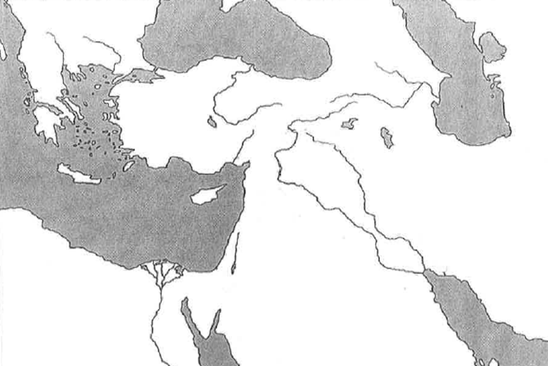
Mediterranean Sea
Nile River
Tigris River
Mediterranean Sea
Euphrates River
Mediterranean Sea
Black Sea
Persian Gulf
Mediterranean Sea
Dead Sea
Red Sea
Fertile Crescent (Use highlighter)

Mesopotamia is between the _______________________ and _______________________ rivers which is why it is called the “land between the rivers.
The most important reasons to live by a river are:
Reason | How it helped

Mesopotamians made both __________________________ contributions and_______________________ contributions.
List three scientific contributions that Mesopotamians invented: _______________________, _______________________ and _______________________.
List three cultural contributions that Mesopotamians invented: _______________________, _______________________ and _________________________________.

 | Government | Cuneiform
What was it used for?
Why is it important today?

Give three specific examples of how a food surplus would help a civilization (Look back to your why live by a river worksheet).
Example: ____________________________________
How it helped: __________________________________________________________________________________________________
______________________________________________________________________________________________________________________________________________________________________________________________________________________________________________________________________________________________________
Example: ____________________________________
How it helped: __________________________________________________________________________________________________
______________________________________________________________________________________________________________________________________________________________________________________________________________________________________________________________________________________________________
Example: ____________________________________
How it helped: __________________________________________________________________________________________________
______________________________________________________________________________________________________________________________________________________________________________________________________________________________________________________________________________________________________
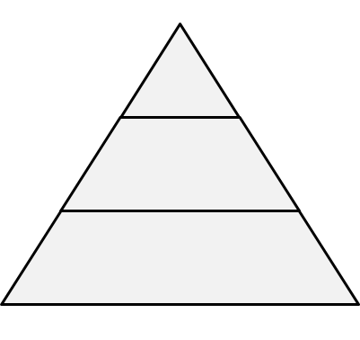
A class system meant that everyone was divided into different social groups. There was an upper class, middle class, and lower class. Label the pyramid with the people who belong to each class (Look at your guided reading for help).

